**Quadratic Function Quiz 4.1-4.3**

**Name:_______________________**

**Block:____________**

For problems 1-4, Graph each function. Identify the vertex and axis of symmetry.

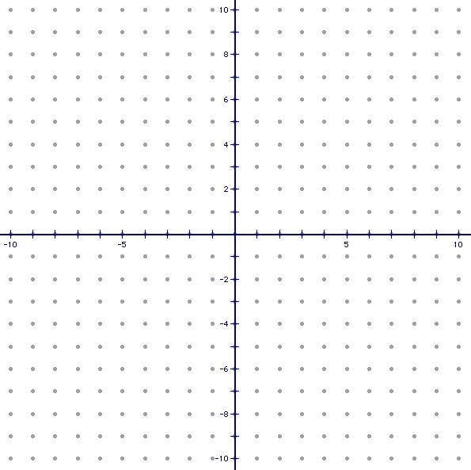





For Problems 5-8, Write the following in Standard Form.

$5.) y=\left(x+2\right)(x-5)$ $6.) y=2\left(x-7\right)(x-1)$

$7.) y=\frac{1}{2}\left(x+4\right)(x+6)$ $8.) y=3{\left(x+1\right)}^{2}+9$

For problems 9-10, Graph each function. Identify the vertex and axis of symmetry.



$$9.) y=x^{2}+4x+1 10.) y=-x^{2}+2x+5$$

For problem 11-12, answer the following questions.

11.) A basketball player shoots a basketball towards a hoop. The basketball follows a parabolic path that can be modeled by the equation $f\left(x\right)={-x}^{2}+5x+2$. If the center of the hoop is located at the point (4, 6) does the player make the shot? Justify your answer. (Draw a picture if needed).

12.) Campers at an aerospace camp launch rockets while attending the camp. The path of the rocket is modeled by the equation $h\left(x\right)=-16t^{2}+150t+1$ where t is the time in seconds and h is the distance from the ground (height). Find the maximum height of the rocket. After how many seconds does it reach this height?